Browser: Mozilla Firefox 85.0 (64-bit)

Task: For the provided page find 3 bugs and write bug reports for them. (Try to find them with different priority)

1. Bug priority: CRITICAL

**Preconditions:** The hotel was successfully booked. A page with booking details (Invoice Number, Booking NUmber, First name, Address, Mobile number) with two buttons "Pay on arrival" and "Pay now" has been opened.

**Steps:** Click on the PAY NOW button> Select Paymenth Method "PayPal"> Click on the "PayPal Check Out" button

**Expected result:** Enter your PayPal information.

**Actual result:** Descriptive error "Things don't appear to be working at the moment. Please try again later.".

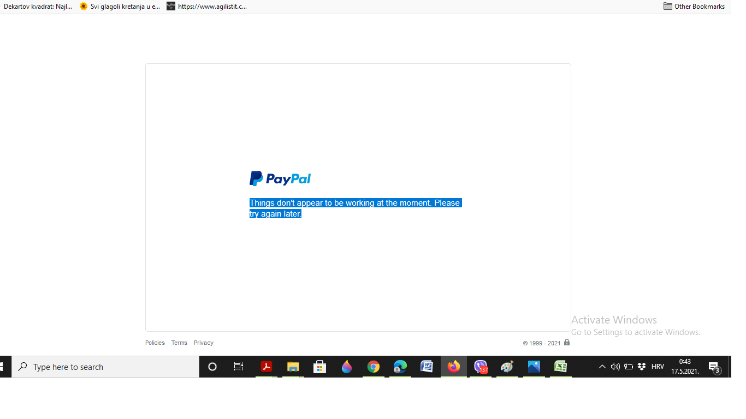

2. Bug priority: HIGH

**Preconditions:** Admin credencial (Username: admin@phptravels.com, Password: demoadmin)

**Steps:** After logging in to https://phptravels.net/admin with access data (Username: admin@phptravels.com, Password: demoadmin) and After clicking LOCATIONS> LOCATIONS> + ADD

**Epected results:** Unable to add locations with invalid parameters.

**Actual results:** Enabled to add locations with invalid parameters.

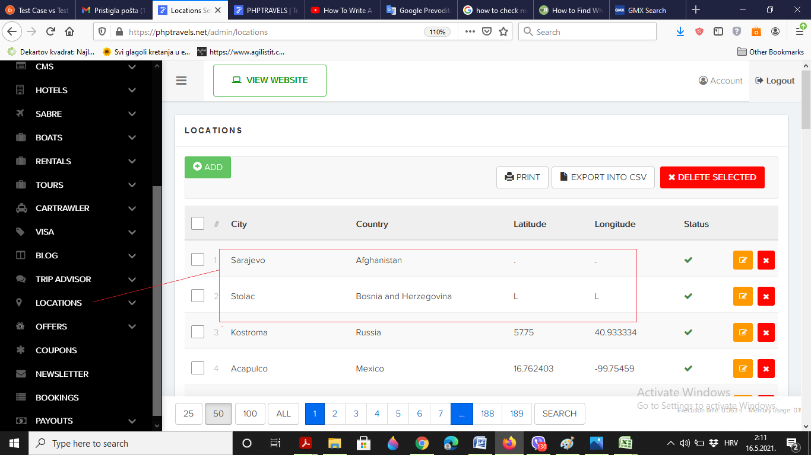

3. Bug priority: LOW

**Preconditions:** Admin credencial (Username: admin@phptravels.com, Password: demoadmin)

**Steps:** After logging in to https://phptravels.net/admin with access data (Username: admin@phptravels.com, Password: demoadmin).

**Expected result:** In the upper right corner there should be an indicator that Super Admin is logged.

**Actual result:** In the upper right corner it says Account (there is no indication that it is an administrator with First name: Super and Last name: Admin).

